

UNIVERSITY of LIMERICK

OLLSCOIL LUIMNIGH

FACULTY OF SCIENCE AND ENGINEERING

DEPARTMENT OF MATHEMATICS & STATISTICS

END OF SEMESTER ASSESSMENT PAPER

MODULE CODE: MA4702 SEMESTER: Spring 2010

MODULE TITLE: Technological Mathematics 2 DURATION OF EXAM: 2.5 hours

LECTURER: Mr J. O’Shea GRADING SCHEME:
Examination: 85% of total marks

EXTERNAL EXAMINER:

INSTRUCTIONS TO CANDIDATES

Answer 5 questions, one each from sections A, B, C, D, and any one other question.

Mathematics tables may be used.

University of Limerick approved calculators may be used.
Section A

1. (a)
(i) Write down the domain and range of the function f(x) = 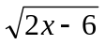.

(ii) Find 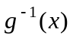 the inverse of the function g(x) =log_{e}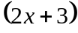.
(iii) Prove that the function f(x) = 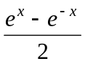 is odd. 10

(b)
(i) Evaluate Sin⁻¹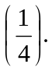
(ii) Sketch the graph of Sin⁻¹ (x) (the principal value of the inverse sine curve) indicating clearly the domain and range of the function. 5

(c) Using their definition in terms of exponentials, prove the following
hyperbolic identity:

Cosh2 x = Cosh²x + Sinh²x. 5

2. Consider the function y = f(x) = x⁴ – 2x²

(i) Find the x and y intercepts of f(x). 1

(ii) Find the three stationary points of f(x) and classify them as local
maxima or local minima. 6

(iii) Find the two points of inflection. 3

(iv) Find the values of x for which y = f(x) is concave up/down. 3
(v) Determine the behaviour of y as x 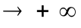and as x 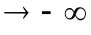. 2

(vi) Sketch the graph of y = f(x) illustrating the features of the curve
obtained in parts (i – v). 5

Section B

3. (a)
Evaluate the following definite and indefinite integrals.

(i) 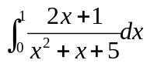 (ii)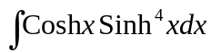.

(iii) Use integration by parts to find 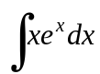. 15

(b) An object moves in a straight line with acceleration a(t)= Cos4t.
At time t = 0 it has a velocity v = 2m/s. Find its velocity at all times t. 5

4. (a)
Find the area enclosed by the curve y = 4 –x ² and the line y = x +2. 10

(b)
Use Simpson’s rule with 4 equal subintervals to find an approximation
for 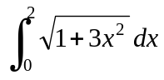 . 10

Section C

5. (a) Find the sum of the telescoping series

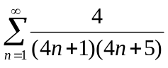 5

(b) Test the following series for convergence.

(i) 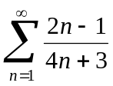

(ii)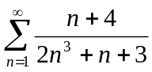

(iii) 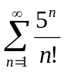 15

6. (a) Find the Maclaurin series of cos x up to an including the term
containing x⁴.

Use your answer to find the Maclaurin series of

(i) cos x²

(ii) sin x 10

(b) (i) Find 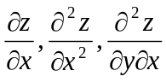of the function z = 2x²y+4xy³+5x².

(ii) Prove that the function z = cos (x+2y) satisfies the partial
differential equation 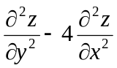= 0. 10

Section D

7. Write down the Maple12 commands which implement the following;
(Do not attempt to find the answers of the Maple 12 output)

- Evaluate 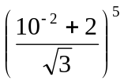to 20 significant digits. 3
- Substitute x =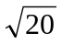into x² +5x. 2

- Find the factors of the cubic polynomial: 2x³ + 10x² -5. 3

- Plot y = Cos x for -5x 5. 3

- Differentiate the following with respect to x: y = 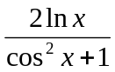 . 3
- Find the second derivative of y = 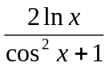with respect to x.
Simplify your answer. 3

- Evaluate the definite integral 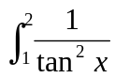dx. 3

- The output of a Maple 12 session, investigating the properties of some function
y = f(x) is represented on the next page.

- Based on this output:

  - Find the x and y intercepts of f(x) (if any).

  - Find the x and y co-ordinates of all maxima and minima turning points of f(x).

  - Find the x and y co-ordinates of all points of inflection of f(x).

  - Discuss the behaviour of f(x) as 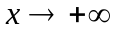 and as . 15

- Based on the information given in the output, plot y = f(x) in the domain
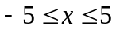, labelling the parts found in (a). 5

Maple output for Question 8

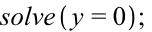
1, 3,4
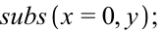
-12
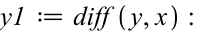
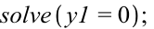
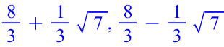
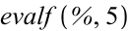
3.5486, 1.7848

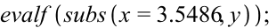
-0.63113033

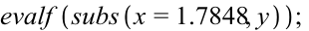
2.11261178

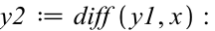

5.2916

-5.2912

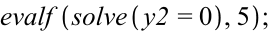
2.6667

0.741

